**S.1 BEGINNING OF TERM 3 EXAMS 2022**

**ICT**

**TIME: 1 HR**

INSTRUCTIONS:

ANSWER ALL QUESTIONS



1. look at a PHOTO MONTAGE of various ICT tools , identify 15 ICT tools and write their functions, by completing the table below

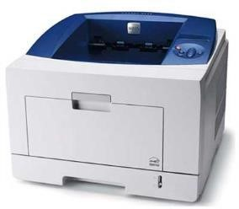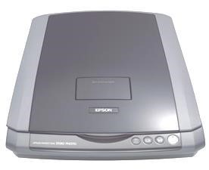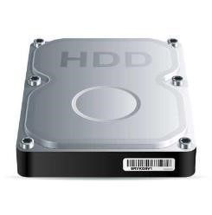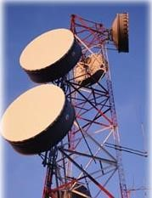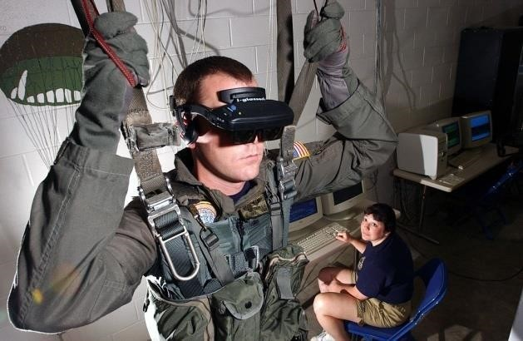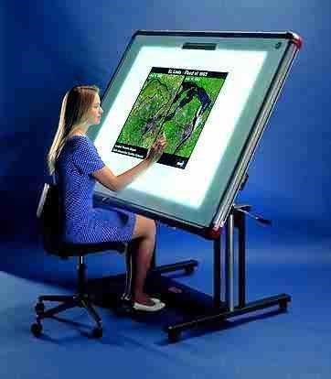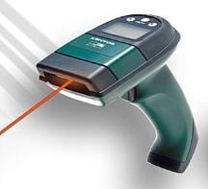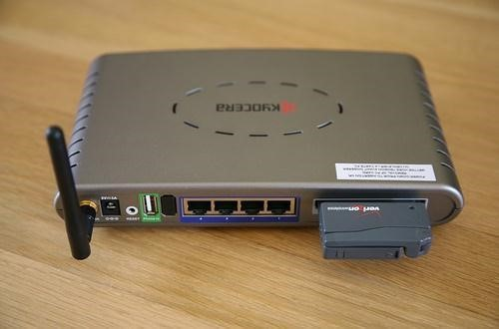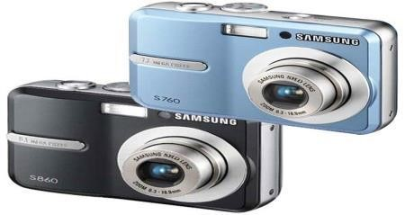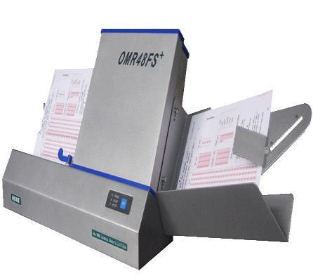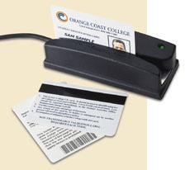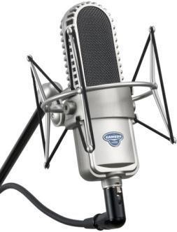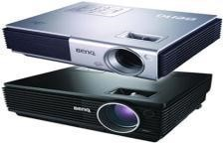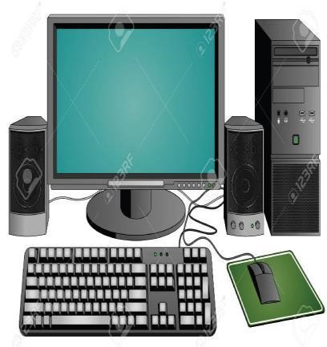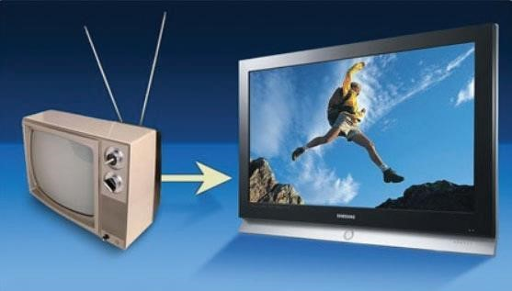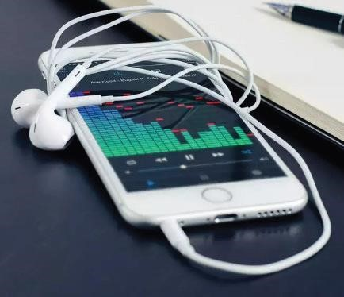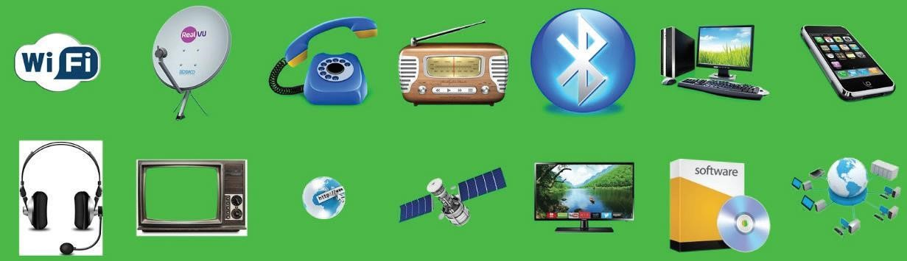

|  |  |
| --- | --- |
| **ICT TOOL** | **FUNCTION.** |
|  |  |
|  |  |
|  |  |
|  |  |
|  |  |
|  |  |
|  |  |
|  |  |
|  |  |
|  |  |
|  |  |
|  |  |
|  |  |
|  |  |
|  |  |
|  |  |
|  |  |

NO. 2. identify a business and the ICT devices used there.

|  |  |
| --- | --- |
| **BUSINESS** | **ICT DEVICE USED** |
|  |  |
|  |  |
|  |  |
|  |  |
|  |  |

**NO. 3.** Discuss FIVE different ways in which a mobile phone can be used as an ICT tool to support business activities.